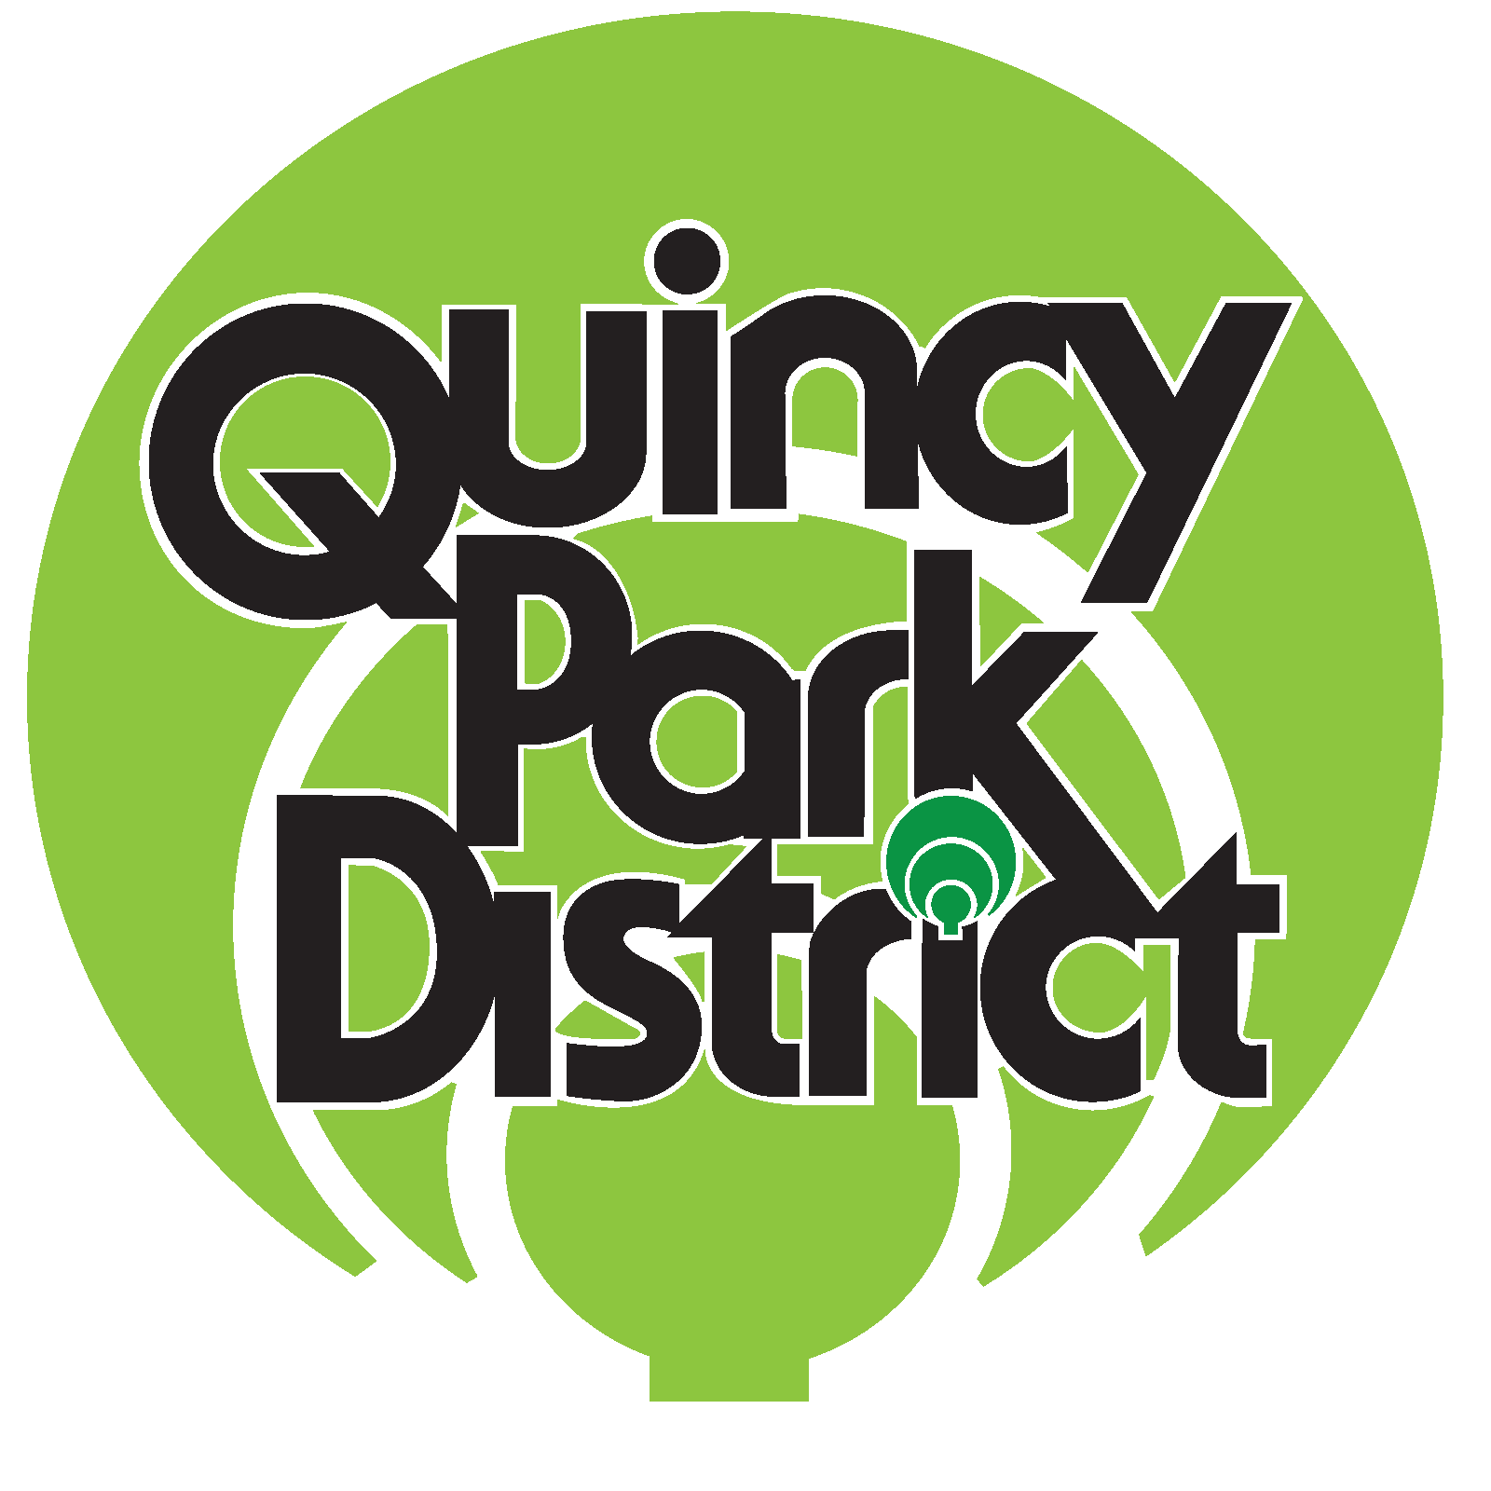

Contact
P:217-223-7703
F: 217-228-9209
info@quincyparkdistrict.com quincyparkdistrict.com
1231 Bonansinga Dr. Quincy, IL 62301
Commissioners
John Frankenhoff
President
Barbara Holthaus
Vice President
Vicki Dempsey
Bob Gough
Nathan Koetters
Roger Leenerts
Jeff Steinkamp
Rome Frericks
Executive Director
Terry Anastas
Attorney

COVID-19 Quincy Park District Update

Quincy Park District COVID-19 Update: March 16, 2020
Due to the pressing need for social distancing and in an effort to support this initiative, the following will be put in place by the Quincy Park District effective Monday, March 16 at 12:00 pm through the end of the month. This includes closing the indoor playground at 1231 Bonansinga Drive. All activities at the Lorenzo Bull House, 1550 Maine Street have been postponed through the end of this month.
All outdoor parks will remain open including Westview Golf Course.
Park District staff will reach out to our customers, programs participants, event organizers, and those who have a facility reserved, with more information over the next two weeks.
- Park District programs that do not exceed 25 participants will continue as planned. Staff will properly sanitize the facility and equipment before and after use.
If a program is canceled, you will be contacted directly by the instructor or other Park District staff.
- We encourage all sports participants and teams not to hold practices until the end of the month.
If you choose to visit our parks, you are urged to follow the recommended protocol as outlined on the CDC Website https://www.cdc.gov/ including:
  - Stay home when you are sick
  - Wash your hands often with soap and water for at least 20 seconds or use hand sanitizer that contains at least 60% alcohol.
  - Avoid close contact with others.
  - Avoid touching your eyes, nose, and mouth.
Quincy Park District continues to monitor the rapidly changing COVID-19 outbreak. Staff and Board remain committed to providing wellness opportunities for our community within the guidelines and recommended protocol provided by the CDC (Center for Disease Control), IDPH (Illinois Department of Public Health) and IPARKS (Illinois Parks Association Risk Services).
Learn more about precautionary measure you can take and the latest updates at the following websites:
https://www.cdc.gov/
http://www.dph.illinois.gov/

