3 on 3 Basketball League

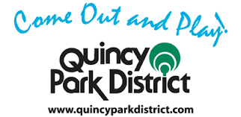

3 on 3 Basketball
Tuesday & Wednesday Evenings
$150.00
Starts June 9th 2020
Registration Deadline May 22nd 2020

Divisions
- 9-10 year old
- 11-12 year old
- 13-14 year old
- 15-16 year old
Registration available at the Park District office
quincyparkdistrict.com
Quincy Park District @QuincyILParks
1231 Bonansinga Drive 217-223-7703

NO REGISTRATION ACCEPTED AFTER DEADLINE

3 on 3 Basketball League Team Roster
Incomplete rosters will not be accepted | All Fields required | Parent signature under age 18
3 on 3  Tuesday & Wednesday Evenings  $150.00  Starts June 9th 2020  Divisions  9-10 year old  11-12 year old  13-14 year old  15-16 year old |  |  | Team Name: __________________________  Coach: _______________________________  Print Email: ___________________________  Cell: _________________________________  Division:______________________________
Player | First & Last Name |  | Print Email | DOB | Cell | Signature
1.
2.
3.
4.
5.
6.
7.
8.
9.
10.
11.
12.
In signing this roster, I do hereby for myself, my heirs, executors and administrators waive, release and forever discharge any and all rights and injuries or damages arising out of this program. I am fully aware that accidents and injuries may occur during the conduct of this program and do fully agree to absolve the Quincy Park District, elected or appointed officials, from all personal liability as a result of my participation in said program.

Coach Signature :_________________________ Address:____________________________

